Geologic Investigations No. 11b North Dakota Geological Survey
By Randolph B. Burke Edward C. Murphy, Acting State Geologist
2005
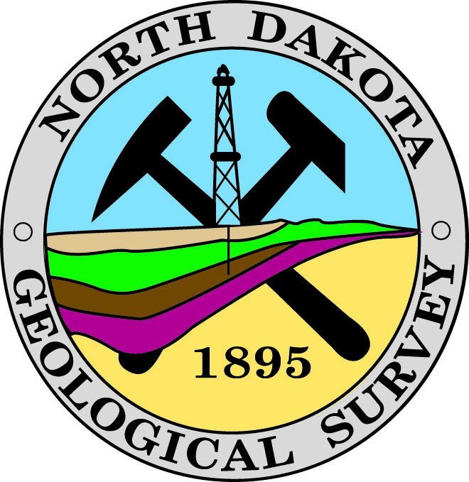

Some Information about CO₂ Evaluation Spread Sheets

Two spreadsheet books are available; one is the “Online Characteristics Summary” and the other is the “Multiple Source Summary”.
The “Online Characteristics Summary” book is a compilation of the numbers we used to draw the conclusions stated in the paper, and slide presentation. Some of these numbers were adjusted when the “NDIC Total Oil Recovery” was greater than, or equal to, 45% using their original data. We used cumulative oil recovery volumes through 12/31/02 as reported by the NDIC (North Dakota Industrial Commission Oil and Gas Division), and a 20% RF to back calculate the values in the “non-NDIC Estimated OOIP” column. The magenta rows in the lavender columns contain the values adjusted to 20% RF. These figures are indicated in the columns labeled “Adjusted”.
The “Multiple Source Summary” book is the compilation of data used to create the “Online Characteristics Summary” book. This spread sheet is provided primarily to document the sources for the data used in making our assessment and to illustrate the range of data that is available. References for data sources are at the bottom of the spreadsheet.
Headings with the abbreviations RN/RB refer to data the authors compiled. The abbreviation RMAG refers to data derived from the Rocky Mountain Association of Geologists.

